**Project Proposal**

Do you have too many games and you can’t decide what to play? Maybe you have a lot of friends coming over or have children playing as well. How will you pick a game that is appropriate for the situation? I am developing a game picker to solve that issue! It will allow you to add new players and their ages and search a game database to pick the right game for you. Have a brand-new game that is not already in the database? No problem! With a fully customizable game database, adding new games is a breeze! Make your next game night a success that will leave all your friends excited for the next one!

Game picker is a simple GUI application that will allow you to add players and search a database to find a game that meets the age/player criteria. You will be able to add and remove players as well as games to the game’s database. The hope is to make managing a game night easier for the hosts.

**Project Plan**

1. Day 1
   1. Create list of default games
   2. Research game age groups
   3. Research game time-to-play
   4. Research game categories
   5. Setup Class Diagram
   6. Environment Setup
   7. Setup Version Control
   8. Develop Database of Games – Dependent on Day1/1-4
2. Day 2
   1. Create Player Object – Dependent on Day1/5-7
   2. Create Game Object – Dependent on Day1/5-7
   3. Create Card Game Object – Dependent on Day2/5
   4. Create Videogame Object – Dependent on Day2/2
   5. Create Boardgame Object – Dependent on Day2/2
   6. Develop Feature: Add/Remove Games – Dependent on Day1/6
   7. Develop Feature: Add/Remove Players – Dependent on Day1/6
   8. Develop Feature: Edit Players – Dependent on Day1/6
   9. Develop 1st Player Randomizer – Dependent on Day1/6
   10. Update Class Design – Dependent on Day1/5, Day2/1-5
   11. Final decision on features – Dependent on Day2/6-9
3. Day 3
   1. Finish any outstanding tasks
   2. Test Code – Ongoing throughout project, but focused on final day
   3. Fix Bugs – Ongoing throughout project, but focused on final day
   4. Optimize Code – Ongoing throughout project, but focused on final day

**Project Requirements**

* User should be able to add/remove/edit players names and ages
* User should be able to add/remove/edit games
* User should be able to set the time intended to play
* Application should be able to determine first player based on game rules
* Application should be able to randomly pick a game that fits the user’s criteria
* Application should do a funny little welcome for each user added, for fun
* Application should be able to display images for the game.
* Application should be able to display console/platform images if required.
* Application should be able to show a brief description of the game
* Application should show the number of players a game is expecting
* Application should NOT show a game that doesn’t meet the minimum number of players or take too much time to play
* User should be able select a category for a game (Videogame, Boardgame, etc.) which would filtering.
* If playing card games, application should tell you what kind of cards do you need (Uno, Standard 52)
* Game database should be editable in and out of application to make the database usable in other applications. (CSV, SQLITE)
* Try to reduce the number of clicks between adding players and finding a game
* Application should include setup times into play time for board/card games

**User Interface Mock-up**

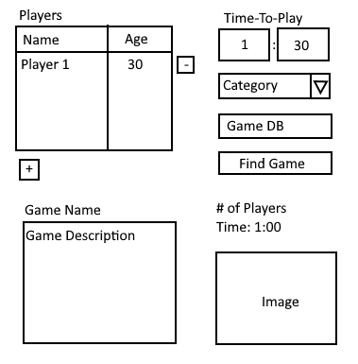

**Class Design**

